ASSIGNMENT – 03
Anyam Akshitha
2303A52453
Batch – 42

Task 1: AI-Generated Logic for Reading Consumer Details

PROMPT:
Generate a Python program to read previous units, current units, and customer type, then calculate units consumed. Keep the logic simple and in the main program.

CODE:
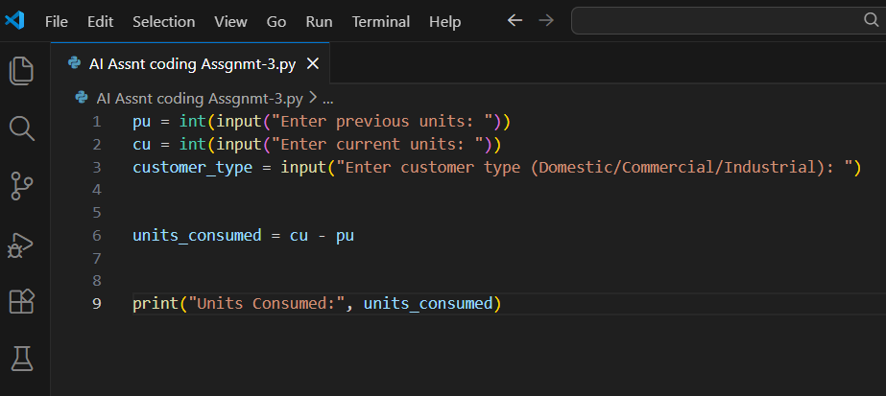

OUTPUT:

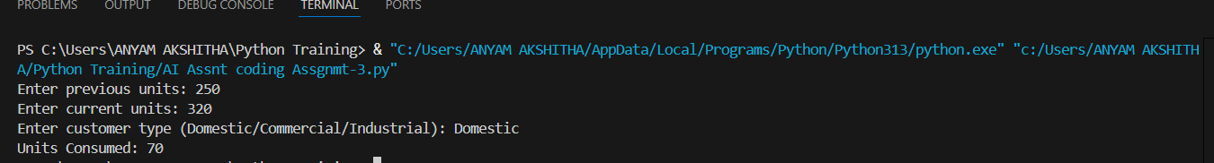

JUSTIFICATION:
AI assistance helped quickly generate correct input-reading logic and arithmetic calculation, reducing manual errors and development time.

Task 2: Energy Charges Calculation Based on Units Consumed

PROMPTS:
Add energy charge calculation based on customer type.
Simplify conditional statements for tariff calculation.

CODE:
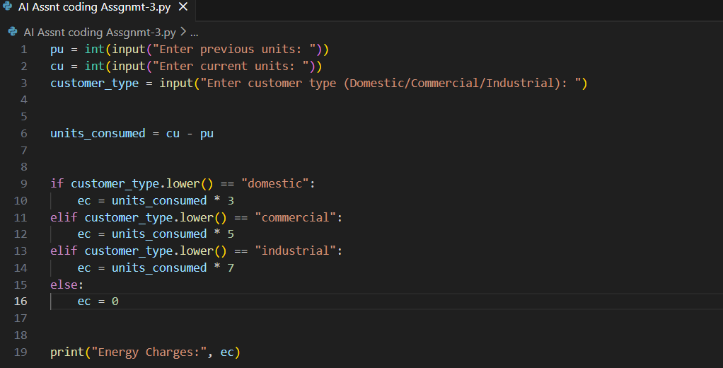

OUTPUT:
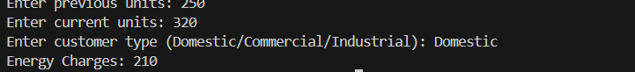

JUSTIFICATION:
AI helped optimize the conditional structure, making the logic more readable and easy to modify for real-world tariff changes.

Task 3: Modular Design Using AI Assistance (Using Functions)

PROMPT:
Create Python functions to calculate energy charges and fixed charges with comments.

CODE:
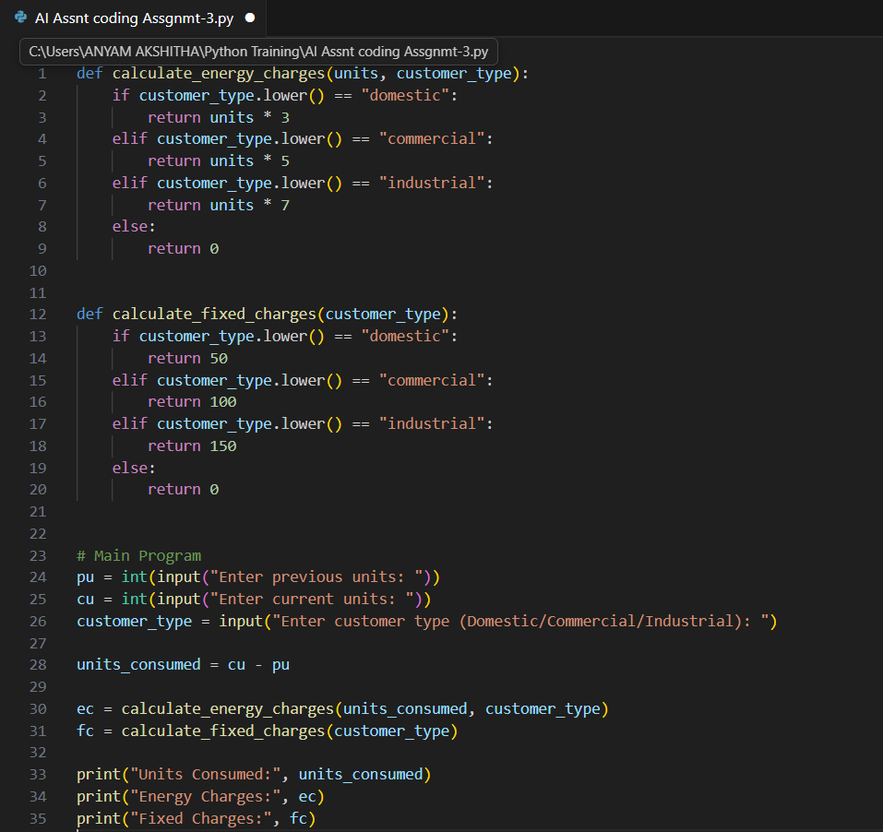

OUTPUT:
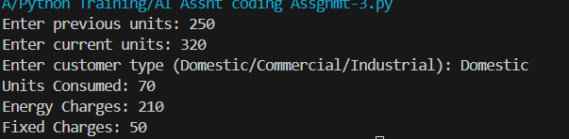

JUSTIFICATION:
Using AI to design modular functions improved code reusability, readability, and maintainability, which is essential for real billing systems.

Task 4: Calculation of Additional Charges

PROMPTS:
Add electricity duty calculation.
Improve billing accuracy.

CODE:
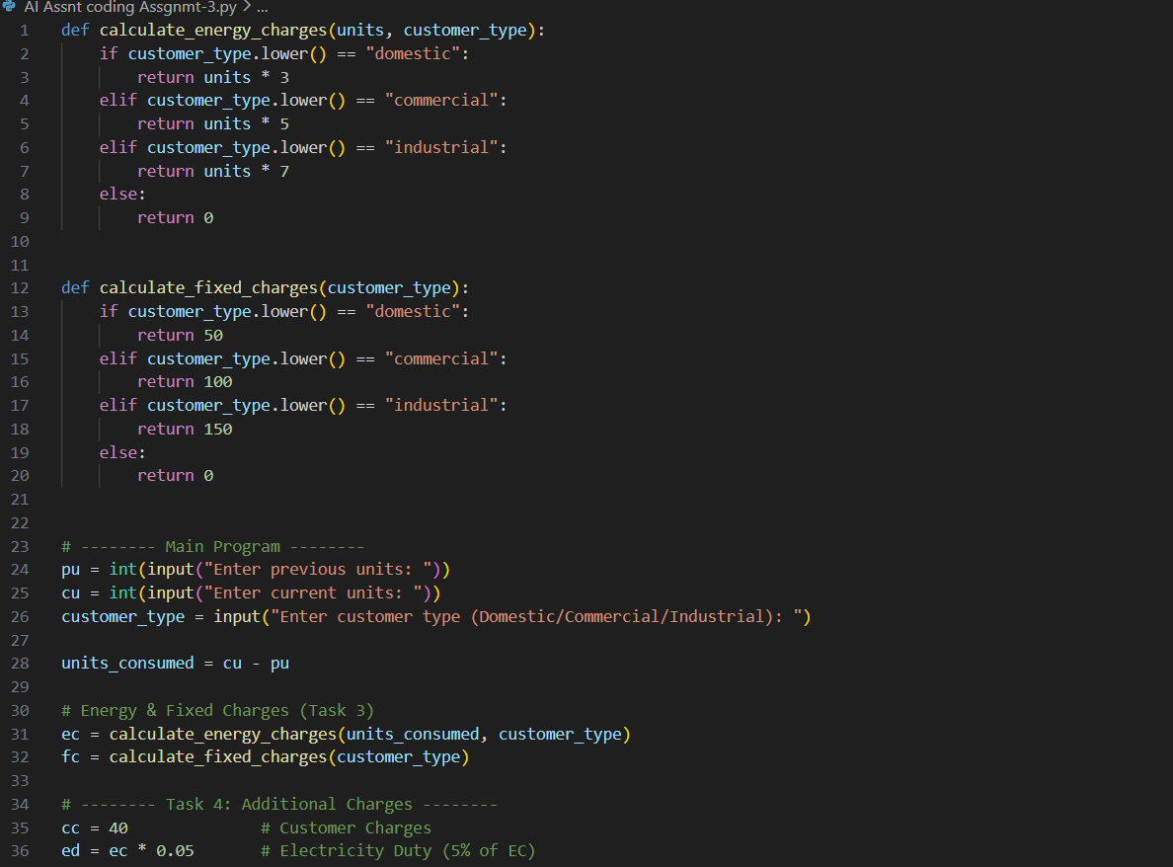
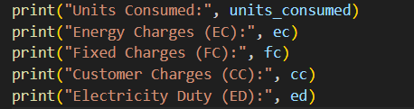

OUTPUT:
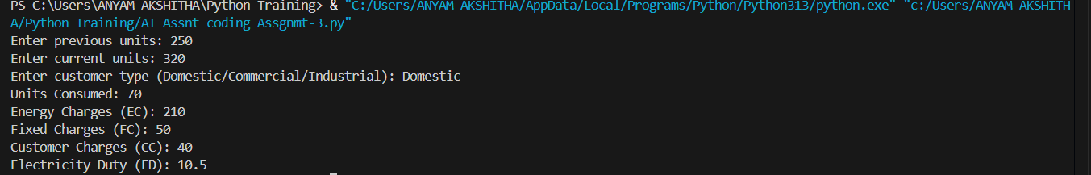

JUSTIFICATION:
AI guidance ensured correct percentage calculations and clear separation of different charge components.

Task 5: Final Bill Generation and Output Analysis

PROMPT:
Generate a Python program to calculate the final electricity bill by summing Energy Charges, Fixed Charges, Customer Charges, and Electricity Duty. Display all bill components clearly in a formatted output similar to a real electricity bill.

CODE:
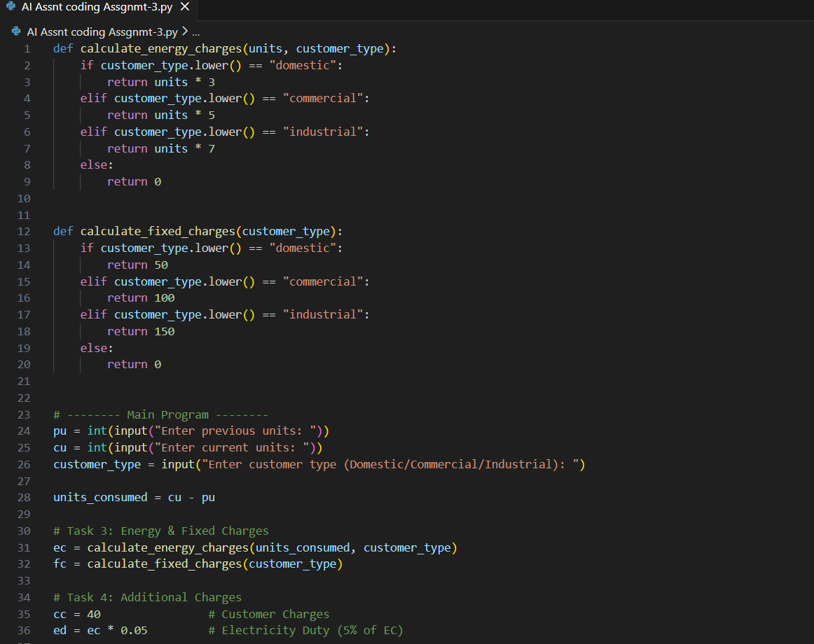
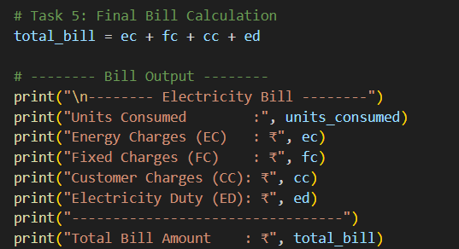

OUTPUT:
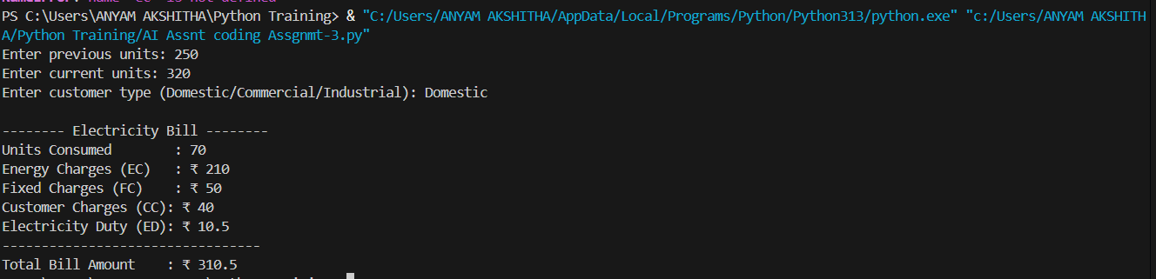

JUSTIFICATION:
The program accurately calculates all billing components using structured and readable Python code. AI-assisted prompts improved logic clarity, reduced development time, and enhanced real-world applicability. The final output resembles an actual electricity bill, fulfilling all lab objectives.

